7 Technology: after Gutenberg and Turing

Soon, if we are not more prudent, millions of people will be watching each other starve to death through expensive television sets.
Aneurin Bevan 1952

Communication technology has shaped and reshaped our world as radio followed the telegraph, television followed radio, and satellites and computers followed in their turn. Broadcasting and the Internet have, in different generations, been heralded as forces that can transform education. Three questions follow: has communication technology shaped the development of open and distance learning, and if so how? How are the technologies being used? Is it all now changing?
Two different ideas have been at play. The first, touched on in previous chapters, has been about the power of a particular technology. Projects have been designed around particular communications media that looked right to address glaring educational needs. Broadcasting has been at the heart of most of these projects. The second idea has been that of combining media: print, broadcasting and face-to-face study. The mixture is common to the radio study groups of Latin America (radio, print, small group, perhaps of a single family), the founding charters of the open universities (across a political divide India and Pakistan both wrote the media-mix idea into their founding documents) and much teacher education (correspondence for educational theory, practical sessions on classroom activity).

BROADCASTING AND TELECONFERENCING

Previous chapters have shown that, at every level of education, some prolects have depended essentially on electronic communication, either for open broadcasting or for teleconferencing. The radio schools of Latin America see it as the principal means of communication with peasant families. Interactive radio instruction is about using radio to raise school quality and sometimes to widen access to it. In Nepal, the project 'Radio Education for Teacher Training' was explicitly designed to exploit and experiment with the power of radio. The Chinese radio and television university system is on a scale that . ) usti 'fies the use of a dedicated broadcasting service. In all these cases, the cholce of medlum has been the starting point for the design of the project.
There are, however, major Kontrasts between the political contexts within which they are working and the reasons for them. The radio schools of Latin America have had continuing access to radio because it is not centrally controlled. Whereas, for a Generation after independence, the former British and French colonies followed metropolitan Tradition in having state broadcasting services, Latin America was always different. As a result, individual, often church-based, nongovernment organisations were free to tun radio stations. The choice of radio as an appropriate technology was determined by the need to overcome isolation in reaching peasant learners.
In dramatic contrast the centralised management of education, and scale of demand, make a dedicated broadcasting system polltically and economically realistic in China. Similarly, the scale of activity of Telesecundaria in Mexico, working with a large number of students at secondary level, and its status as a government programme have made the continuing use of television possible. (For television, this option is realistic only for a relatively large country.) In both these cases the scattered distribution of the audience was one reason for selecting broadcasting but the scale of the demand was even more significant. Broadcasting was needed to reach large numbers.
The Interactive Radio Instruction projects, discussed in chapter 3, were different again. They generally used national radio stations by agreement with the relevant ministry of education. There was no need to seek new radio facillties where ministries of education already ran school broadcasting. Radio made sense for the large numbers of school children potentially or actually involved. The projects can be seen as technology-driven in the sense that the funding agency set out to demonstrate the value of radio, rather than neutrally seeking the most appropriate means to an educational end (see chapter 8).
While these broadcast-based projects can be seen as driven by technology, broadcasts are not, of course, the sole teaching medlum. In China, for example, there were, in 1990, over 500 courses available, with 294 options to be fitted into 84 television teaching hours per week by satellite broadcast and a further 22 hours distributed by microwave link (NIME 1993: 41-3). Textbooks and tutors are needed to cover some of the ground: even on the scale made possible by a dedicated channel there are not enough broadcasting hours to cover the whole curriculum. Guldes for teachers and students are a necessary part of the teaching System.
Problems of Isolation have led to experlments with satellite communication and teleconferencing. As seen in chapter 5, teleconference links have been used on a sustained basis by both the University of the South Pacific and the University of the West Indies in order to reach students on small islands.
In both cases the imperative was to reach audiences who could not be expected to move to the campus for the whole of their education and who were living in territories that were funding the university. The costs of telecommunication technology - borne in significant part by external funding agencies - were justified by geography. This form of distance education was not, therefore, an alternative to something print-based, but an alternative to the regular on-campus, or occasional off-campus, teaching that could not be provided to territories without a campus. In both cases, too, the technologically determined use of satellite communication has been backed by the development of courses that rely much more heavily on print.
We can sum up that there is a small number of examples in which the nature of a distance-education programme has been determined by a particular communication technology, usually broadcasting, sometimes teleconferencing. Access to broadcasting has been a function of polltical control. The choice of technology has, in turn, been driven by numbers or geography, the need to reach many students or to overcome severe problems of distance and Isolation.

MIXING THE MEDIA

Many, if not most, distance-teaching institutions have set out with the intention of using a variety of media, including broadcasts. A combination of media is likely to be more effective, perhaps by keeping up motivation, perhaps because some aspects of a subject lend themselves to a particular medium, perhaps because the timing imposed by regular broadcasts or seminars keeps students working." Different media may compensate for each other's weaknesses. Broadcasting is particularly important as a means of reaching audiences immediately, regardless of distance. lt also has a unique capacity to attract attention from potential students, from the general public and from decision-makers. Presence on a national radio or television service legitimises distance education. Ram Reddy, the founding vice-chancellor, told the story of his attempt to persuade a new chief minister in Andhra Pradesh that the planned open university needed to be based in Hyderabad and not in a remote town with no facilities or infrastructure. lt was the proposed use of television that surprised the chief minister, a former film actor, and swung the argument (cf. Reddy 1997: 115-6).
While the idea of mixing the media, and in particular of harnessing broadcasting to a new style of education, was a potent one, in practice it has been difficult to achleve. Despite a wish to move away from old-style correspondence education, many institutions, at all levels of education, are now making minimal use of any medium other than print. We look at each sector in turn.
As we saw in chapter two, there was an early expectation that combinations of media, including broadcasting, would be used on a wide scale to support rural development and nonformal education. But the expectations of ' an expansion of public service broadcasting and communications, epitomised by Schramm's 1964 title, Mass media for national development, were not upheld. The MacBride report on mass communications in 1980 and the Maitland report of the International Telecommunication Union in 1984 argued that investment in telecommunications would bring economic benefits, but led to little action (MacBride et al. 1980; Independent Commission for Worldwide Telecommunications Development 1984). As distance education expanded in the 1980s, it did so in an environment where there was limited public funding for, or interest in, communications for development. INADES-formation illustrates the result. Although earlier reports referred to occasional radio series in some of the countries where it was operating, its use of radio had apparently fallen away by 1996-7. (An initiative from a Canadian nongovernment organisation 'Réseau des radios er revues totales de l'Afrique francophone' suggested a possible new beginning (INADESformation 1997: 43).) Its work is dominated by print and face-to-face sessions.
Both secondary-level and teacher-education projects have made limited use of broadcasts or of recordings, with the obvious exception of the broadcasting-based projects such as Telesecundaria and Interactive Radio. The open schools of India and Indonesia, for example, make some use of recordings, but have not seen radio or television as a priority. The National Open School of India has a half-hour broadcast a week (National Open School 1999). In the past, correspondence study centres in central Africa had limited access to radio but this has declined and print dominates their work. Teacher education has not generally been able to attract broadcasters, and those tunning distance-education programmes have seen the organisation of teaching practice as more important than seeking broadcast time.
At tertiary level there have been more sustained attempts at using a mixedmedia approach (see chapter 5). Some of the Asian open universities (e.g. in Bangladesh, India, South Korea, Pakistan, Taiwan and Thailand) have some access to open-circult broadcasting (Latchem et al. 1999). The national open universities in India and Pakistan built their own studios and Pakistan has discussed the possibillty of establishing a dedicated educational broadcasting channel. Others make extensive use of tape recordings. Universiti Sains Malaysia, for example, uses teleconference facillties and has made some use of videocassettes and audiocassettes, although'it notes that 'Print is the principal teaching material used by the Centre' (NIME 1993: 179). Many dualmode universities lack access to airtime and use audio or videocassettes on a limited scale with little or no broadcasting." Some large open universities are in the same position: Universitas Terbuka in Indonesia has not bullt broadcast studies and estimated that print provided 96 per cent of its teaching with audio tape providing 2 per cent and radio, television, teleconferences and tutorials each providing 0.5 per cent (ibid: 107).
Print dominates. At least until the advent of direct-broadcast satellites, and perhaps beyond, it probably has to, except in the small number of programmes which, for good reasons of numbers or geography, have been driven by telecommunications. The idea of combining media, and the potential and publicity of broadcasting, have glven distance education an impetus as it has expanded since the 1970s. But, with important exceptions, the demands of broadcasting technology have not driven the process.
Table 7.1 sets out some illustrations of the use of technologies and the domination of print.

THE NEWER TECHNOLOGIES

Perhaps this is all changing. The last decade has seen changes in communication technology which may have profound effects on open and distance learning. They include changes in satellite technology and changes in the price, availabillty and power of computers. The growth of the Internet has speeded and transformed communication between those who have access to it.
Many of these changes have affected educational institutions along with everyone else. Wordprocessors have transformed the production of distanceteaching materials in just the same way as they have changed business correspondence around the world. Email links and access to literature in electronic format are doing something to reduce the Isolation of academic staff in the universities of the south. But, computer technology opens up some specific possibilities to the distance educator who may consider its use for tutoring, for distributing, and for teaching.

Computers in distance education

First, tutoring. Overlooked by technological forecasters, faxes came first. They helped to internationalise distance education. Once students could communicate with tutors by fax, it was quick and easy for universities in the north to teach, and keep in close contact with students in the south - provided they lived in capital cities or middle-income countries and could afford the Telephone charges. Only modest investment was needed for a fax machine, something that was generally regarded, at least at first, as something for an institution or at least a department rather than an individual. The University of Sheffield, for example, runs a number of specialist master's courses for which it recruits internationally. Students are expected to use fax or email to send their assignments. Email produced subtle changes and new demands, as it is generally available only where users at both ends have access to an individual computer. As a result, while it allows easy communication between tutor and student, it is avallable only to the relatively privileged and demands a higher level of investment than fax. Neither fax nor email produce dramatic changes in the way a course works; they simply make contact faster.

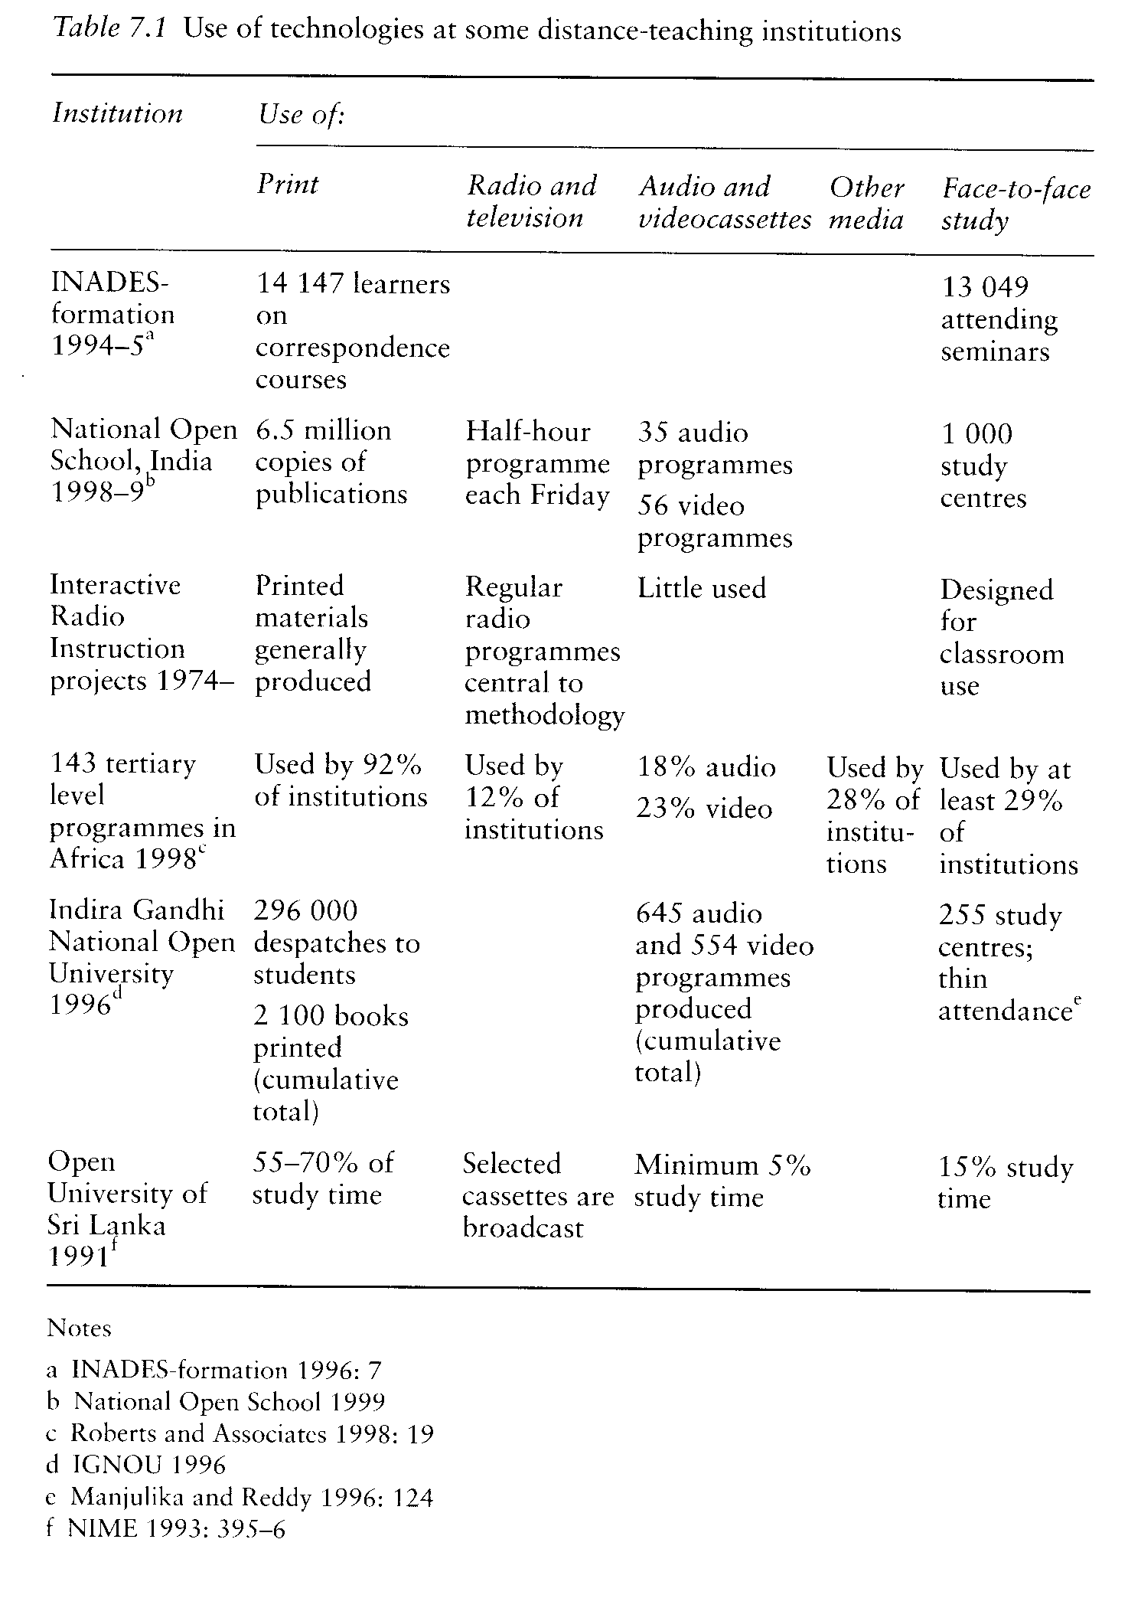
Next, distribution: computer links mean that course material can be delivered electronically. On the face of it this is an attraktiv option, reducing distribution costs and postal delays, or at the least passing on distribution costs from the Institution to the student.

But there are disadvantages. An outline plan for expanding distance education at the University of the West Indies,for example, suggested that material should be developed centrally but then downloaded electronically to the resident tutors in the university's fourteen territories (Renwick et al. 1992: 66). This proved impracticable; resident tutors did not have the staff to print, collate, staple and store the range of units needed for even a modest number of courses, nor did they have the reprographic equlpment necessary to produce them to the requisite quality. There is a danger that distributing materials electronically merely shifts the cost from producer to user and results in the user having an inferlor version of the material.
Then, teaching. lt is possible to develop a whole course in a variety of rnedia, make this available through the Internet and use the same technology for contact between student and tutor, and among students. Computer links, in principle, make it possible for students in any location to be treated as a single group - once any language barriers are overcome. The most highly developed examples are from the north. The British Open University, for example, offers a master's programme in distance education. Students download teaching materials from the Weh, contact their tutors through email, and are encouraged to take part in computer conferences as part of the course. (Half do, half don't, even of this self-selected and technologically Kompetent group.) Whereas the use of computer links for tutoring or for the dellvery of material is built on to an existing course without changes to its structure, the development of an Internet course of this kind means that students can enrol directly on to a different kind of course. Constraints on enrolment are no longer a matter of geography but of access to the Internet and the ability to pay the enrolment fee and costs of communication.
There are beginning to be examples of this in the south, though more often within a framework of north-south Kooperation than of indigenous southern development or, indeed, south-south Kooperation. The Monterrey Institute of Technology, for example, a well-established and high-status private university in Mexico, has worked with the University of British Columbia to develop five Web-based courses at master's level in educational technology. The programme is specialised, attracting students in hundreds not thousands, and has enabled Monterrey to extend its teaching into an area that would not otherwise have been possible. Significantly, however, all the teaching material was developed at the University of British Columbia, in consultation with colleagues from the Monterrey Institute. The new technologies have made possible a new framework for inter-university Kooperation but this still follows the same pattern of the north-south export trade (Bares and Escamilla de los Santos 1997).
Computer technology may, therefore, begin to reshape open and distance learning - for the minority of the world with ready access to Computers and cheap telecommunications. Universities in the north are fully aware that new technologies make it possible for them to reach new audiences but also that their status and relationships are changing as they compete in new ways with each other for students, and with developing corporate universities and agencies. Communication technology, in which distance is no bar to enrolment, facilitates and feeds that competition (CRE 1996). Within the industrialised north, virtual universities have begun to talk about challenging the conventional. A virtual university would be able to enrol students, and, using the Internet, provide teaching to students globally. We come back below, to the policy issues such a development will raise.

The African Virtual University

The World Bank has begun to use computer technology in order to establish an African Virtual University. The Bank argues that a virtual university, using satellite communication and computer networks to share teaching, could help the beleaguered universities of Africa improve the quallty of their teaching in science, engineering and business and expand enrolments in these areas. The World Bank and other funding agencies have provided start-up funding, apparently of between $5 million and $10 million but with the intention that it should in due course become self-supporting." Its starting point was that it would be a virtual Institution, avoiding the costs of buildings. The virtual university would develop, or buy in, computer-based teaching material and make this avallable to African universities by franchising existing courses or developing new ones on demand. The plan envisaged that

In the early stages of the project, the courses will be bought from established producers of course and educational materials: curriculum products; reference materials and databases; multimedia conference proceedings; multimedia learning packages; software application tutorials; and computer simulations. In later stages AVU will engage in the production of top quallty instructional material in Africa by Africans.
(Baranshamaje n.d.: 4)

As well as being a broker the university would also have a quallty control function, work with its African partners in developing student support, and help them with their management (ibid.).
The African Virtual University is being established in three phases: a pilot, testing feasibillty, an operational phase in which some complete degree courses would be made available, and a third 'transition to Africa phase' in which Materials would be originated within Africa. In the pilot phase (1997-9) equipment was set up, with twenty-seven satellite recelver terminals initially being installed in fifteen countries (World Bank 1998: 55). Television-based teaching was carried by satellite from universities in Canada, Ireland and the United States to universities in five of the countries involved. In some cases there is an audio feedback link providing one-way video and two-way audio. Courses were at undergraduate level in mathematics, physics, chemistry and computer science. At Makerere University in Uganda, for example, 324 students took part in twelve courses in the trial phase in 1997-8 (Aguti 1999b: 5). Alongside this export of television courses, AVU has begun to offer digital access to on-line journals and to train staff within Africa on the use of the technologies the virtual university will use.
With the African Virtual University we are back to a project that is technology driven. While its aims are defined in terms of ralsing quallty and widening access, the Institution is made possible only by the current state of development of telematics. Its choice of methodology seems to have been made because the technology was there rather than because of an appraisal of the merits of different ways of developing materials collaboratively or of sharing them across frontiers.

Satellites

Much satellite technology is hidden and demands no decisions from educators: the Telephone company decides whether to route calls terrestrially or by satellite. But changing technologies, including new communication satellites, may offer educational opportunities and possibly lead to a reshaping of distance education and of broadcasting's role within it. In 1995 a consortium including the American Hughes Communication group and the Cisneros group in Brazil launched a Galaxy satellite with the potential to provide 192 channels of digital audio and television programmes direct to listeners in Latin America. Broadcasts were planned to be in the Ku band so that any user would need to buy a separate receiver to be able to receive the broadcasts. The consortium has offered to make satellite capacity available both to the World Bank and to the University of the West Indies. The World Bank called a meeting of Latin American educators in 1997 to explore what kind of programming could be made avallable, across frontiers, and on the scale that would justify investment in the software and the use of the satellite. Agreement was not easy to reach. Similarly in Africa, Worldspace is launching satellites that will provide direct broadcasting and has also announced that it will make channels avallable for educational purposes. The commercial company has set up a separate charity to allocate time on the channels. Again, a new recelver will be necessary at a cost estimated in 1999 at between $250 and $500.
These technological changes are shifting the balance of costs. The capacity of the new Generation of direct-broadcasting satellites is such that the cost of the satellite transponder is no longer significant: a commercial company can afford to make space available on the satellite, drawing income from the others that are used for entertainment. The significant technical costs have moved to the ground, for the development of uplinks, and for the extensive investment needed by the public in new receivers. And the costs of producing good teaching material remain.
More technological drivers? With imagination, the satellite developments may bring opportunities for an expansion of educational broadcasting and of mixed-media distance-education programmes. Without it, we may simply have a costly medlum seeking a role. In the case of the African Virtual University, for example, it is difficult to see how the add-on costs of importing teaching material by satellite will be sustainable for hard-pressed universities. lt is even more difficult to see how the technology could widen access. lf importing teaching materials is the answer, there are other and cheaper ways of doing it.

POLICY ISSUES

The new technologies raise, once again, policy issues that are famillar within international education but do so from a new angle. They concern access, student support, costs and culture.
Learners need to have access to the equipment needed to do anything more technologically demanding than read books. Radios, television sets or computers need to be available at affordable prices. Direct broadcasting satellites will need a new receiver. All equipment needs a power supply: batteries for radio, rural electrification for television, a guaranteed and rarely interrupted power supply for computers. There needs to be a service industry capable of maintaining equipment. To use the Internet, the user will need a service provider and to be able to meet the costs of this and of line charges, both likely to be higher, in real terms as well as in relation to earnings, in the south than in the north. These requirements already restrict access. Courses that depend on computer-based technology may be appropriate for small audiences and in specialised subiects, but cannot at present reach the large, often rural, audiences of many of the world's distance-teaching institutions. New technologies may narrow rather than widen access.
Questions about student support arise in relation to the remote enrolments made possible by the new technologies. Will the need to provide student support on the ground limit the significance of this to a handful of offerings, perhaps in highly specialised areas, or will courses from metropolitau institutions successfully recruit and teach throughout the south? lf they do recruit, they can be expected to do so at a price that only the rich can afford so that the development is likely to be socially regressive.
Sound decisions about using new technologies need to take account of their costs. Unfortunately few recent data are disaggregated in a way that enables us to compare the costs of teaching media. But figures are avallable from recent research within Europe carried out by the International Research Foundation for Open Learning within a project funded by the European Union Socrates programme. Their significance is not so much in the actual figures as in the relationship between them.
In order to make comparisons between different media, the project looked at the cost of producing materials in terms of student learning hours and found that, as a rough guide, it was costing European tertiary-level institutions about £500 ($825) to produce the text, or print version, of material

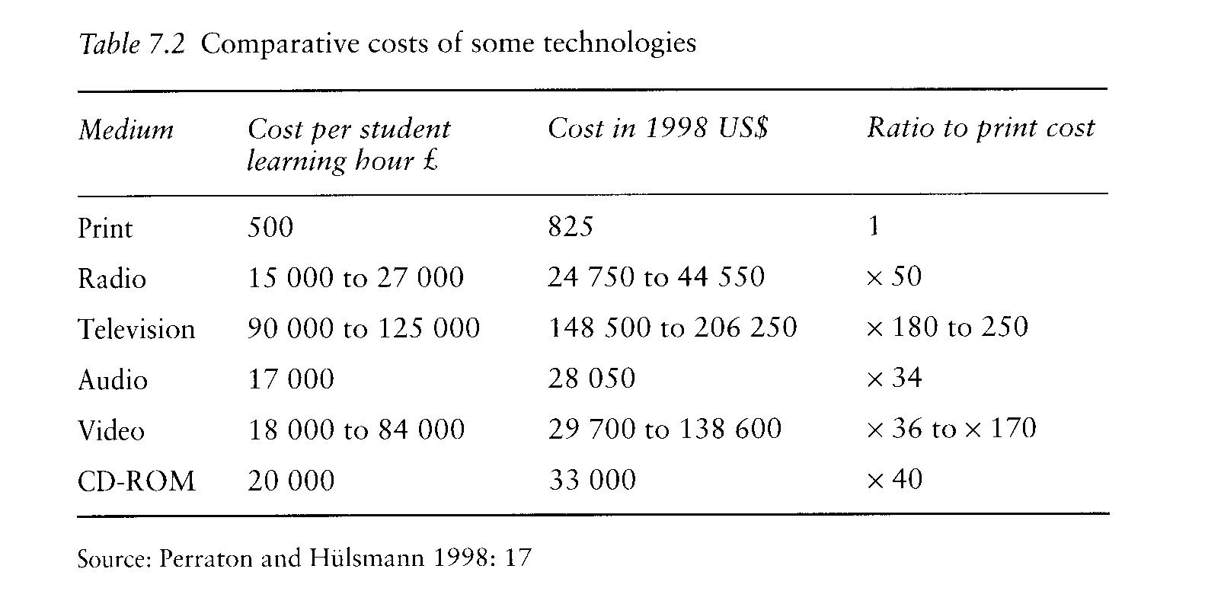

that would occupy a student for one hour. Using audio or radio was likely to increase the cost 30 to 50 times, with television or video significantly more. lf Computer communication was used to distribute printed material, unchanged, then costs should be no higher than for conventionally printed material. But the use of a medium that allows sound, and simulation, or the inclusion of fllmclips, encourages producers to make use of these other facillties. lt was found that simply adding a small number of hyperlinks to printed materials would increase costs two to three times while a well-developed cdrom, using a variety of visual material, was likely to increase costs 40 times. Indicative costs are in table 7.2.
There are two warnings here. The first is that, while institutions may save time and money on distribution lf they move from print to computer, any savings are likely to be overwhelmed by increased production costs if they seek to use the variety of opportunities that computer-based learning makes possible. Second, while the costs of broadcasting and of computer-based material are similar, and both are much higher than the cost of print, broadcasts or recordings are usually used for only a small part of the teaching whereas the move from being print to computer-based is likely to affect a whole course and so have a much greater effect on total costs.
lf we move from costs per medium to costs per degree, a new question arises in connection with global enrolment. Will the universities of the south be at a competitive advantage or disadvantage? The prestige of a degree from the Sorbonne, or Oxford, or Harvard is bound to attract students internationally - though none of these universities has been at the forefront of this kind of technological development. But it will do so at a price that reflects academic staff costs in a rich country. In contrast, universities in the south may be able to compete on price with those of the north, in just the same way as the Indian computer software industry successfully attracts business from North America.
Finally, the scale of investment needed for computer-based teaching and learning provokes questions about the source of teaching material. There are, of course, powerful arguments that, as information technology is of ever-growing economic significance, so national investment in software and hardware is an inescapable priority. This may lead to pressure to use computers on an ever-larger scale for education within institutions and beyond despite the costs of doing so. But the level of investment required to produce computer-based materials may mean that developing countries find they cannot afford to develop their own. lf so, materials from the private and public sector in the north are likely to dominate. Expanding computer-based education may increase northern cultural hegemony.

CONCLUSION

Technology excites, opens some possibilities, closes others. In the midnineteenth century the advance of the telegraph to Constantinople meant that London could keep in daily touch with affairs in the Balkans and SouthWest Asia; it was not welcomed by the British ambassador Stratford de Redcliffe, who immediately lost the freedom to make up his own policy. Today, while the cost of much technology has been declining dramatically, many advances may restrict access, rather than widening it, by putting more costs on the user. In much of the south courses available on computer will reach the rich, or those at work in the modern sector; they will cut out the poor, the remote, and those not employed in the modern sector. This process will hurt women more than men.
The evidence on the development of distance education in the south suggests a number of other cautions. For the most part, while it may have been driven by the idea of using a range of technologies, it has not been technologically driven. Rather, there has been a cautious and restricted use of any technology other than print, backed by limited opportunities for face-to-face study. The exceptions, including the large programmes of secondary education in Mexico and tertiary education in China, are important. More often, technologically driven projects seem to have been at risk. The early television experiments and Interactive Radio have seldom proved sustainable. In analysing the reasons for this we would need to disentangle the role and cost of technology from the fact that these were generally attempts to ralse quality in school, in practice adding to unit costs rather than using technology to reach new audiences. But they offer at the least a warning to the newer computer or satellite-based projects.
Computer and satellite communication is only beginning to affect open and distance learning in the south. Virtual universities may yet play a malor role in the south and in the north: we do not yet know. We can, however, see that there are social, economic and cultural risks that will follow in the wake of the new technologies. Caveat innovator.
One more caution. The powerful idea of distance education was to use a variety of approaches for out-of-school audiences, doing something more interesting and more effective than old-style correspondence education. The institutions now using open and distance learning have been producing teaching material of a new quality. At the same time, the near-abandonment of rnedia other than print means that teaching is less varied, less interesting, perhaps less effective than we had hoped for in that dawn. Radio, to reiterate, remains underused. We know that it is a powerful tool for public education with modest unit costs, but one that has largely slipped into the background. There may be a danger of grasping tomorrow's technology and neglecting yesterday's.

